UNVEILLING MARKET INSIGHTS: ANALYSING SPENDING BEHAVIOUR AND IDENTIFYING OPPORTUNITIES FOR GROWTH

1. INSTRODUCTION:

* + - Collect detailed data on your spending habits, if you’re a business, your financial
* Compare your spending behaviour to industry behaviour to industry benchmarks or your own historical data. This can help you see where you stand.
* If your financial are complex, consider consulting a financial advisor or accountant. Businesses can involve financial analysts.
  1. OVERVIEW:
* Gather detailed information about spending habits and patterns, including income, expenditures, and saving.
* Compare spending patterns with industry or peer benchmarks to gain insights into relative performance.
* Evaluate spending against a budget or financial plan to assess alignment with financial goals.

1.2: PURPOSE:

* This can be done to discover areas for improvement or potential investment.
* If you have specific questions or need assistance in this, regard, please feel free to ask.
* Analysing spending behaviour to identify opportunities for growth typically involves tracking and examining on individuals or organization’s financial acts.

1. PROBLEM DEFINITION AND DESIGN THINKING:

2.1 EMPATHY MAP: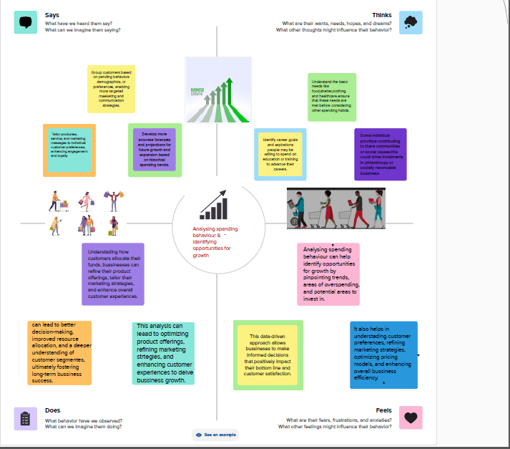

2.2 IDEATION AND BRAINSTORMING MAP:

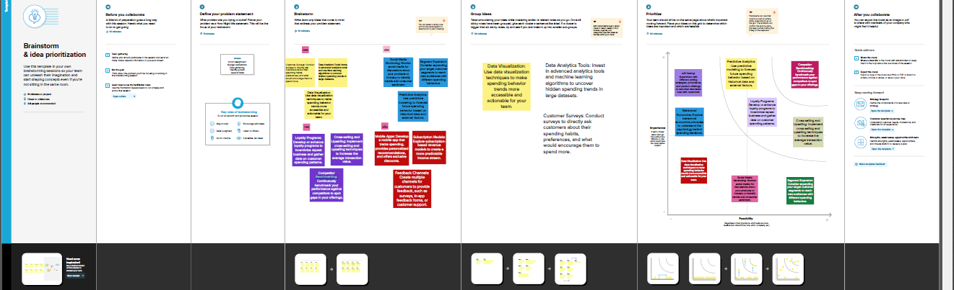

3.RESULT:

**DASHBOARD AND STORY**

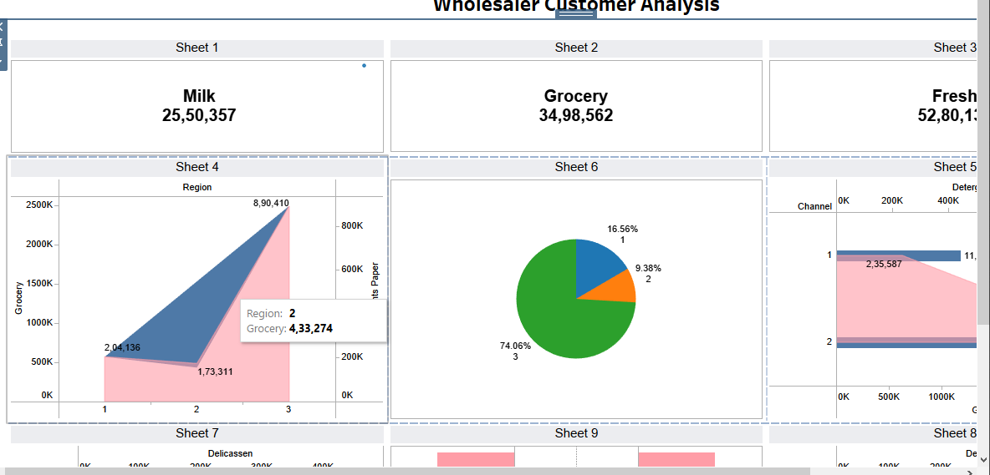:

4: ADVANTAGES AND DISADVANTAGES:

ADVANTAGES:

* Continuously track your financial performance to ensure you're moving toward your growth goals.

1. Be prepared to adjust your strategy as needed. Spending behaviour can change, and your analysis should evolve with it.
2. Identify which expenses are critical for your business and which may be cut or reduced without harming operations.
3. Be prepared to adjust your strategy as needed. Spending behaviour can change, and your analysis should evolve with it.
4. Sort expenses into categories (e.g., marketing, overhead, employee salaries) to understand where your money is going.

DISADVANTAGES:

* Analysing spending behaviour can be complex, especially for large organizations with diverse expense categories
* The process can be time-consuming and may require significant resources in terms of staff time, software, and data collection.
* The accuracy and completeness of your financial data are crucial. Inaccurate or incomplete data can lead to incorrect conclusions.
* Focusing solely on cost-cutting in the short term may hinder long-term growth and innovation.
* Analysing financial data requires careful handling to protect sensitive information and maintain privacy compliance.

5: APPLICATIONS:

* Apps like Mint, Quicken, or Personal Capital can help track and categorize spending, offering insights into where your money goes.
* Apps like Mint, Quicken, or Personal Capital can help track and categorize spending, offering insights into where your money goes.
* Apps such as YNAB (You Need A Budget) help in creating budgets and monitoring expenses, aiding in better spending behaviour.
* Some financial apps use machine learning algorithms to predict future spending and suggest ways to optimize your financial decisions.

6.CONCLUSION:

* In conclusion, analysing spending behaviour and identifying opportunities for growth is a strategic process that involves gathering and analysing data, segmenting customers, and making informed decisions to optimize spending.
* By understanding customer preferences, managing costs, and adapting strategies, businesses can unlock opportunities for growth
* It's an ongoing process that requires a commitment to data-driven decision-making and a keen focus on customer satisfaction and market dynamics.

7.FUTURE SCOPE:

* The future will see increased emphasis on financial literacy and education to empower individuals and organizations to make more informed spending decisions.
* Changes in financial regulations and policies may impact how spending behaviour is analysed and managed
* AI and machine learning algorithms will be used to predict spending behaviour and offer personalized financial advice.
* Personal finance apps and platforms will continue to grow, offering users the ability to track their spending behaviour and receive